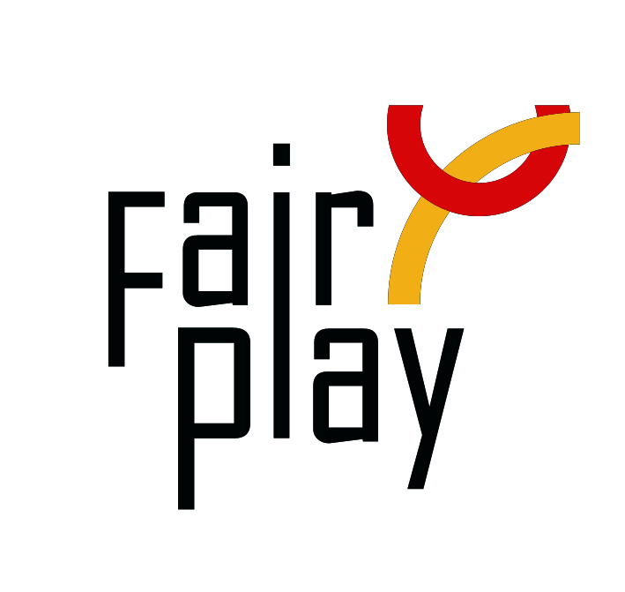
SUBMISSION OF CANDIDACY
QUESTIONNAIRE FOR C.I.F.P. AWARDS NOMINATIONS 2022

The C.I.F.P. awards distinctions for fair play under the following category each year:
Willi Daume World Fair Play Trophy
to a person or organization for an activity aiming at promoting
Fair Play by organizing national or local campaigns, giving lectures, writing articles in the press, or making comments on the radio or television;

- Details of the person or organization proposed for the nomination:

Name (Ms./Mr./organization) and country:

E-mail:

Profession or current occupation:

- Description activities promoting fair play:
Local level: (max. 50 words)

(Inter)national level: (max. 50 words):

- Description connection with aspects of fair play:

- Source (preferably in English):

________________________________________________________________

Details of the person or organization submitting this nomination:

Name:
E-mail:

Date:

Please attach all available supporting evidence (photos, press clippings, reports etc.) justifying this nomination as well as a PHOTO
_________________________________________________________________________________

The CIFP awards are the following in the ascending order of merit:

I. Letter of Congratulations,
II. Diploma of Honor,

III. World Fair Play Trophies

Fully substantiated candidacies for 2022 World Fair Play Awards can be submitted by 28 February 2023 to the below address:

E-mail: nominations@fairplayinternational.org

International Fair Play Committee
Attn. Dr Jenő KAMUTI – President

H-1124 Budapest, Csörsz u. 49-51. Hungary

