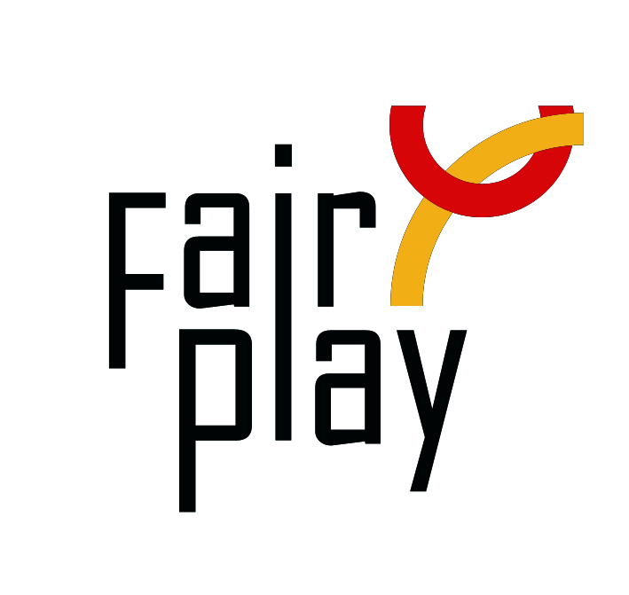
SUBMISSION OF CANDIDACY
QUESTIONNAIRE FOR C.I.F.P. AWARDS NOMINATIONS FOR THE YEAR 2022

The C.I.F.P. awards distinctions for fair play under the following category each year:

Pierre de Coubertin World Fair Play Trophy
to an athlete, or a team, for an ACT of Fair Play that cost, or could have cost
his/her victory, or could have downgraded his sport performance;

- Details of the person or organization proposed for the nomination:
Name (Ms./Mr./organization), country:

E-mail:

Profession or current occupation:

Date of the act:

Place of the act (city, country):

Name of the competition:

- Description of the act (max.100 words):

- Source (preferably in English):

- Connection with aspects of fair play:

___________________________________________________________________
Details of the person or organization submitting this nomination:

Name:
E-mail:

Date:

Please attach all available supporting evidence (photos, press clippings, reports etc.) justifying this nomination as well as a PHOTO
_________________________________________________________________________________

The CIFP awards are the following in the ascending order of merit:

I. Letter of Congratulations,
II. Diploma of Honor,

III. World Fair Play Trophies

Fully substantiated candidacies for 2022 World Fair Play Awards can be submitted by 28 February 2023 to the below address:

E-mail: nominations@fairplayinternational.org

International Fair Play Committee
Attn. Dr Jenő KAMUTI – President

H-1124 Budapest, Csörsz u. 49-51. Hungary

