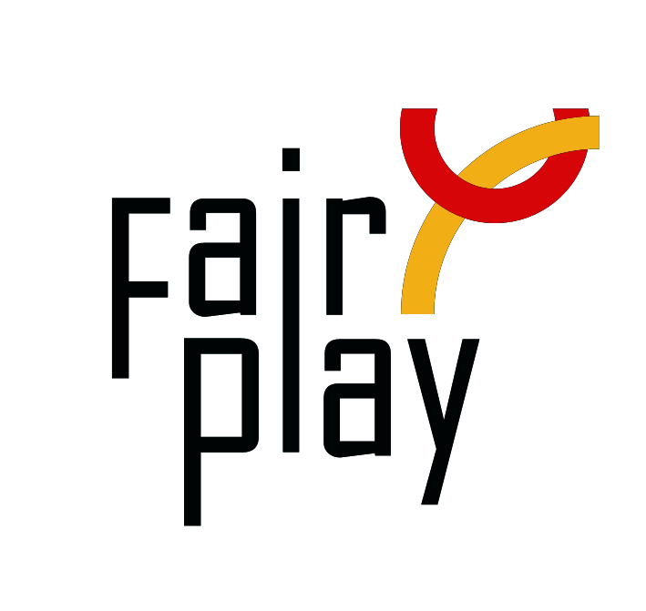
SUBMISSION OF CANDIDACY
QUESTIONNAIRE FOR C.I.F.P. AWARDS NOMINATIONS 2022

The C.I.F.P. awards distinctions for fair play under the following category each year:

Jean Borotra World Fair Play Trophy
to a person for his/her remarkable general attitude
showed all along his/her sport career, for an outstanding and constant spirit of fair play, for observing the unwritten rule of sport not to take advantage of an opponent's bad luck;
-----------------------------------------------------------------------------------------

- Details of the person or organization proposed for the nomination

Name (Ms./Mr./organization), country:

E-mail:

Profession or current occupation:

- Summary of the sport career and sport performances (max. 50 words):

- Summary of other functions in sport (trainer, sport official):

- Description connection with aspects of fair play:

- Source (preferably in English):

___________________________________________________________________

Details of the person or organization submitting this nomination:

Name:
E-mail:

Date:

Please attach all available supporting evidence (photos, press clippings, reports etc.) justifying this nomination as well as a PHOTO
_________________________________________________________________________________

The CIFP awards are the following in the ascending order of merit:

I. Letter of Congratulations,
II. Diploma of Honor,

III. World Fair Play Trophies

Fully substantiated candidacies for 2022 World Fair Play Awards can be submitted by 28 February 2023 to the below address:

E-mail: nominations@fairplayinternational.org

International Fair Play Committee
Attn. Dr Jenő KAMUTI – President

H-1124 Budapest, Csörsz u. 49-51. Hungary

